Welcome to the DMPS Middle School
Online Physical Education
Healthy Bodies. Healthy Minds.

2020-2021 School Year
Instructor: Mr. Lundgren
Contact Info: scott.lundgren@dmschools.org

Course Description for Middle School Online Physical Education
Course Info: You will learn how to make SMART goals to align with your self-improvement in health and wellness, FITT Principle, Components of Fitness, a variety of skills, strategies, and tactics, and track your daily physical activity.
Grades: 6, 7, 8
Physical Education is an important and unique part of the daily instructional program. Not only does it contribute to the overall goals of education, but it also contributes to the development and maintenance of fitness, motor skills, social skills, health, and brain development.

Course Requirements
This course is designed to completed in one semester. It is recommended that you follow the pace of the modules and due dates in order to complete the class on time. If at any point you have any questions regarding pace or instruction, please feel free to reach out to me via Canvas or Teams.
You may need the following materials in order to be successful in this class:
- ball that bounces, balloon, or a sock ball

Attendance:
Students are required to attend all virtual sessions at the respective time. Any absences should be communicated to the instructor. Attendance will be taken for each scheduled class meeting. The first half hour of class will be online and students need to be active and participating to be considered present. The second half hour of class is designed for individual or group activities.

Telecommuting and Virtual Learning
(VC Example) Just as students have the ability to complete their schoolwork wherever they choose teachers also have the same ability. It is highly encouraged that a student reaches out to their teacher if there is an individual need to ensure availability. The most ideal way to get help will be to reach out to your teacher through Microsoft Teams.

Communication Policy
All teachers maintain regular working hours during the day just like teachers who work in classrooms throughout Des Moines Public Schools. Teachers can be reached through Microsoft Teams and email. Teachers also adhere here to 2-hour response time or less during the workday and depending on the time in which the communication is sent, the teacher may not respond until the next day of business.
Scott Lundgren – available via teams and answering questions on canvas from 8:30-12:45 and 1:15-3:45 when not in a class. Scott.Lundgren@dmschools.org
Diana Repp – available via teams and answering questions on canvas from 8:30-12:45 and 1:15-3:45 when not in a class Diana.Repp@dmschools.org

Digital Citizenship
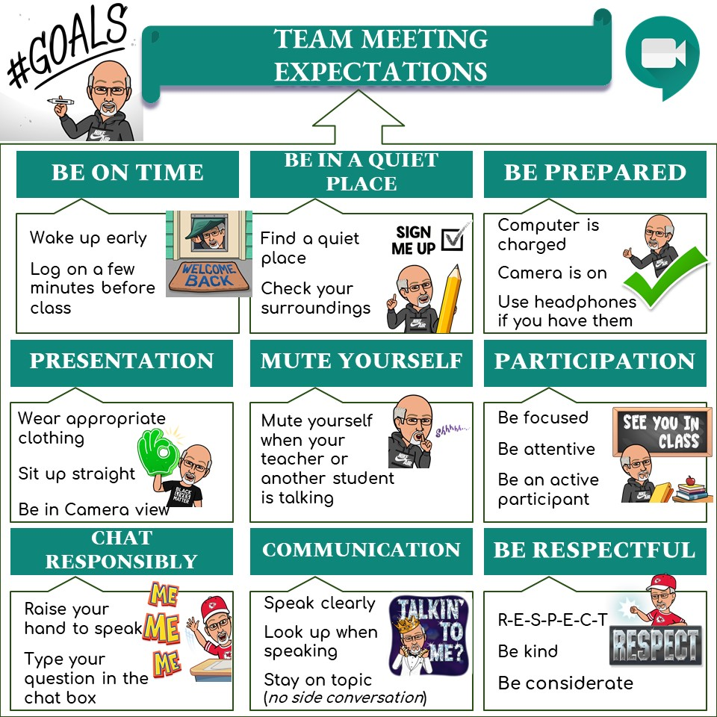

Grading Policies and Procedures
All courses in Canvas will have a built-in grade book where students can view feedback on each assignment a student completes. While Canvas is where students complete all of the coursework and where daily grades can be seen.

Grading Scales
Final grades on Canvas will follow the format below.
International Baccalaureate Feedback
