Des Moines Public Schools
21st Century Community Learning Centers
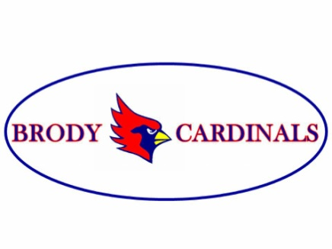
BRODY MIDDLE SCHOOL SUMMER PROGRAM
Thanks to a 21st Century Community Learning Centers grant Brody Middle School is pleased to announce summer programming available beginning June 8 and running through July 17. The FREE program will be held at Brody Middle School. The summer program is open to all in incoming sixth graders and current Brody students.
Brody Summer School Program Details:
- June 8 – July 17
- 9:00 am – 2:00 pm
- free breakfast served at 9:00 and free lunch at 12:30
- Classes in the morning, students will choose among STEM, cooking, arts, web design and games
- Physical education classes after lunch
- Attendance is flexible— students can attend partial or full days, one week, two weeks, three weeks or all six weeks
- Brody does not provide transportation to or from the program

Register online at the link below.
https://fs8.formsite.com/DMPSchools/form126/index.html
Direct any questions about the program to site coordinator, Judy Pauley, at Judith.pauley@dmschools.org.

